**DIGITAL ASSIGNMENT – 2**

Abstract:

The memory architecture for the System should be immediate and secure. So here I modified allocation of process in paging concept to remove external fragmentation and I used extent based file system to extract the information quickly.

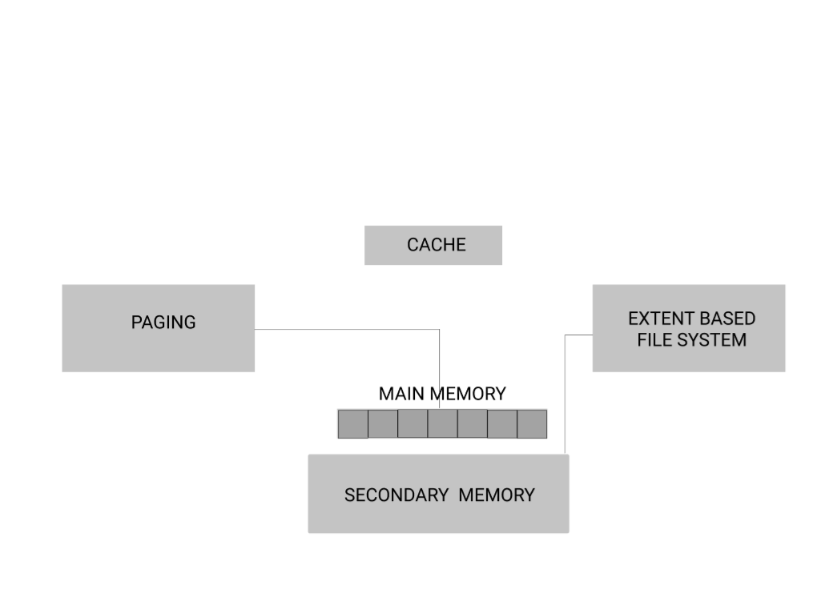

**Implementation:**

In paging, instead of using FIFO I have modified it to reduce external fragmentation and apparently more number of process can be allocated to the memory

At first will be placing all the process in the main memory through first in first out.

Then we will be shifting all the process to one side and making other side available.

This will reduce the external fragmentation while allocating process in main memory.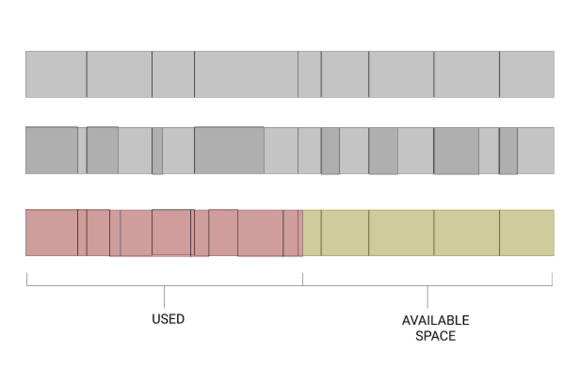

In extent based file system, we will be extracting files as bulk amount Instead of using pointers concept to retrieve files from main memory.

It will reduce the time consumption of to retrieve information from main memory.

This can help us saving time when we want to extract continuous data like array.

It will first collect the address of head and then it will retrieve the information of next address by adding file size to it.

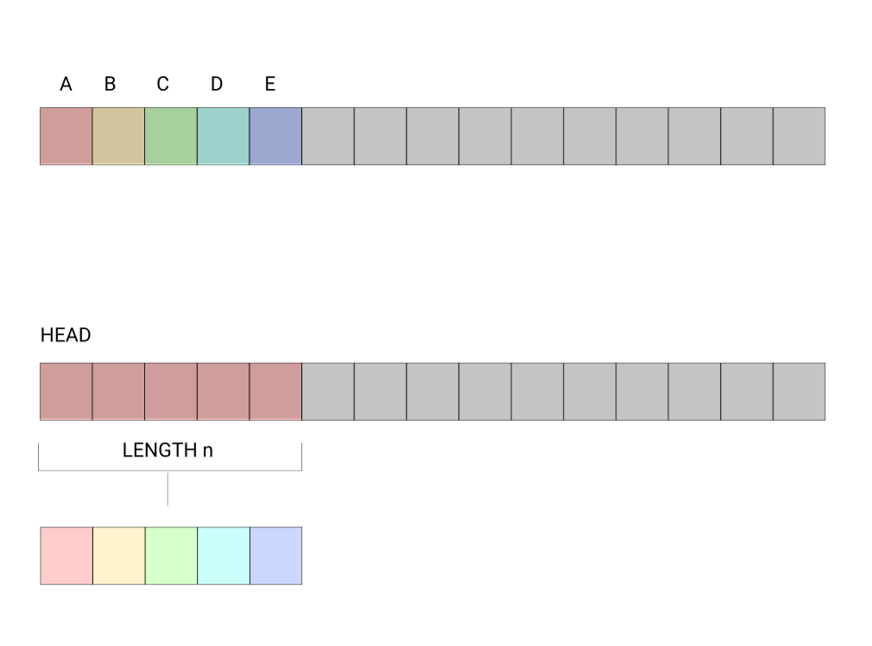

Memory management is all about allocation and optimization of finite physical resources.

Our own aim is to reduce the computational time and increasing the available space in main memory to execute any type of process easily.

We can use SSD to boot the applications fast.

We can increase the amount of space for SSD than HDD.

If we make all application programs and some required system applications to be in SSD. It will make system even faster. The more space in SSD the more process executes faster.